**Project Design Phase-II**

**Data Flow Diagram & User Stories**

|  |  |
| --- | --- |
| Date | 16 October 2022 |
| Team ID | PNT2022TMID23220 |
| Project Name | Detecting Parkinson's Disease using Machine Learning |
| Maximum Marks | 4 Marks |

**Data Flow Diagrams:**

A Data Flow Diagram (DFD) is a traditional visual representation of the information flows within a system. A neat and clear DFD can depict the right amount of the system requirement graphically. It shows how data enters and leaves the system, what changes the information, and where data is stored.

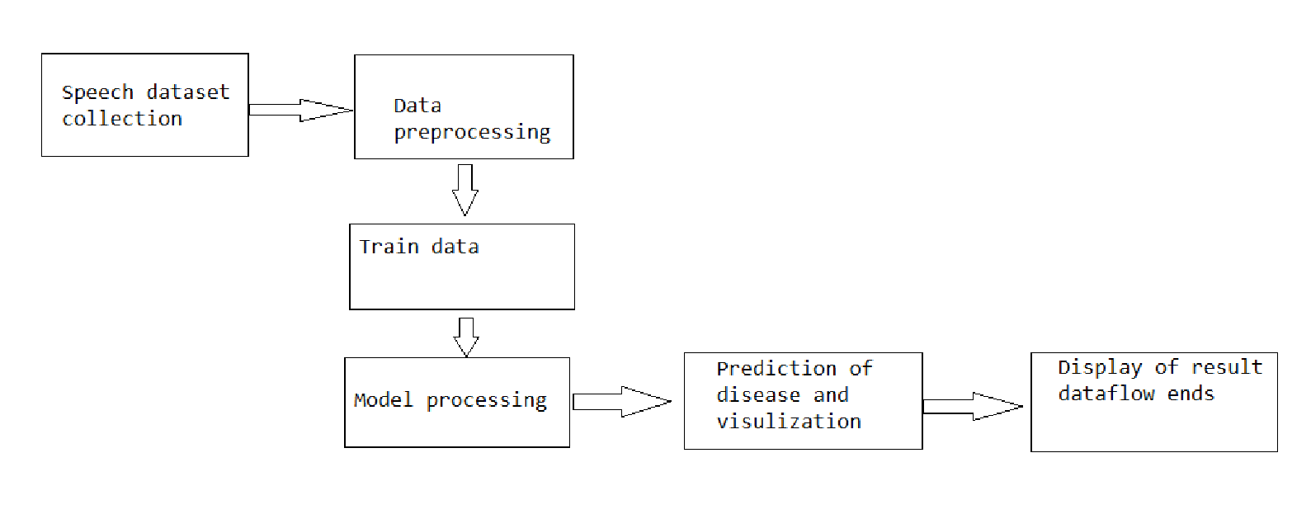

**User Stories**

| **User Type** | **Functional Requirement (Epic)** | **User Story Number** | **User Story / Task** | **Acceptance criteria** | **Priority** | **Release** |
| --- | --- | --- | --- | --- | --- | --- |
| Customer (Mobile user) | Registration | USN-1 | As a user, I can register for the application by entering my email, password, and confirming my password. | I can access my account / dashboard | High | Sprint-1 |
|  |  | USN-2 | As a user, I will receive confirmation email once I have registered for the application | I can receive confirmation email & click confirm | High | Sprint-1 |
|  |  | USN-3 | As a user, I can register for the application through Facebook | I can register & access the dashboard with Facebook Login | Low | Sprint-2 |
|  |  | USN-4 | As a user, I can register for the application through Gmail | I can register for the application through Gmail | Medium | Sprint-1 |
|  | Login | USN-5 | As a user, I can log into the application by entering email & password | I can log into the application by entering email & password | High | Sprint-1 |
|  | Dashboard | USN-6 | user can view their profile, speech recognition, handwritten drawings detection, user’s data sets, visualizing the final result, logout | I can view their profile, speech recognition, handwritten drawings detection, user’s data sets, visualizing the final result, logout | Medium | Sprint-1 |
| Customer (Web user) | Login credential | USN-7 | As a web user can register the patient details and entering the mail id, password  after the completing registration user can direct to the dashboard page which contains profile, speech recognition, handwritten drawings detection, user’s data sets, visualizing the final result, logout | I can register the patient details and entering the mail id , passsword after the completing registration user can direct to the dashboard page which contains profile, speech recognition,handwritten drawings detection, user’s data sets, visualizing the final result, logout | High | Sprint-1 |
| Customer Care Executive |  | USN-8 | Executive helps to find the solution for the problems faced by the customer | I can solve the problems faced by the customer,  I can check out their details if needed,  I can clarify their doubt | High | Sprint-3 |
| Administrator | database | USN-9 | Admin stores the user data’s | I can store the user data, | High | Sprint-1 |
|  | authentication | USN-10 | Admin has the access for user data and other secured information | I can access the user data like change the values, delete the values,  I can also change authentication priority | High | Sprint-1 |
|  | updates | USN-11 | Admin has the rights to update the application | I can update the application if needed (to satisfy user requirements) | High | Sprint-1 |
|  |  |  |  |  |  |  |